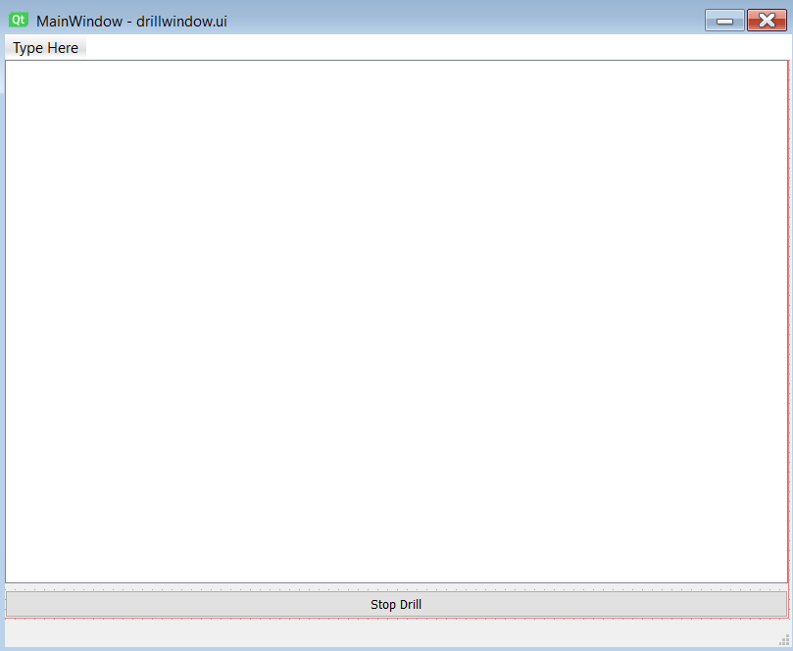

# Reps = 5

# Look Downs = 2

Time: 00:12:459